*JAWS 2: Incident at Arched Rock*

*By Dave Cone*

*Originally published in Bay Currents, Nov 1993*

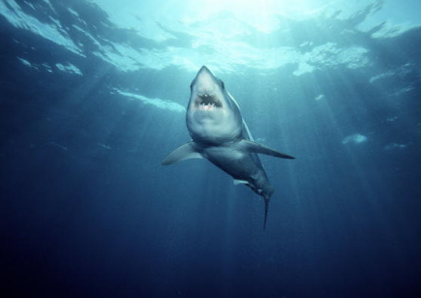This time we can joke about it-nobody got hurt. For the second year in a row, autumn in Northern California was marked by a Great White Shark attack on a coastal kayaker.

Rosemary Johnson is a lifelong ocean sports enthusiast now living in Sonoma County. On Sunday October 10, she and three companions set off from Goat Rock Beach south of Jenner for the short paddle southward to Arched Rock (another Arch Rock lies north of Jenner). Rosemary was paddling a borrowed blue Frenzy, which is a plastic sit-on-top boat just nine feet long. Her friend Rick Larson, on his second kayak trip ever, was on a Scupper, and one of the others paddled a Kiwi, which is also a very short kayak.

As the **f**o**u**r paddlers approached Arched Rock, Rosemary veered off from the group and headed around the rock. Rick and the others soo**n** followed at some distance. Rosemary felt a power**fu**l jolt and flew off the top of her boat. Rick saw a shark perhaps 16 feet long knock the boat entirely out of the water, a**n**d he believes Rosemary flew 12 to 14 feet into the air. Rosemary landed in the water, and briefly felt something solid underfoot. She thinks she landed on the shark. Wearing a wetsuit but no life vest, she had to swim in one direction to nab her paddle, then back the other way to get to her boat. She remained calm, believing that she had merely struck a rock. Her approaching companions were less than calm, having seen the "monster" that hit her boat. Rick states that the shark's mouth encompassed almost the whole width of the Frenzy.

Rosemary hopped back on her kayak, but immediately capsized. She re-entered a second time and attempted to head toward shore, but had difficulty controlling the boat. When she capsized again, her friends saw the bite marks on her hull and realized that her boat was tippy and unmanageable because it was taking on water. They quickly improvised a rescue, with Rosemary riding belly down and head aft on the **f**ront of Rick's Scupper-"the only boat that could take me"-and the other paddlers towing the punctured boat. The group ret**u**r**n**ed to the beach without further difficulty.

Back on dry land, the party reported the incident to Sonoma State Beaches rangers and inspected the boat. The damage measures 20 by 15 inches and lies entirely below the waterline approximately beneath the seat. A jagged crack runs perpendicular to the line of tooth marks. The pattern differs from the evidence left on Ken Kelton's boat, which shows tooth marks on both deck and hull (see "Ano Nuevo Revisited," Bay Currents, Dec. '92). Ken's shark held his boat for five to ten seconds, while Rosemary's contact was a collision rather than a grab-and-shake. Although it's common for sharks to intentionally release their prey after the initial attack, it is also possible that this shark simply bit more than it could chew, and Rosemary's boat popped out of its jaw like a watermelon seed between your fingers.

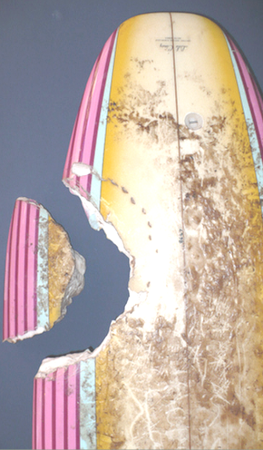A researcher at Bodega Bay Marine Lab told the state park folks ***the size of the bite marks is consistent with a Great White up to 14 feet and 1500 pounds***. Photos of the bite mark have been sent to shark expert Dr. Mark Marks at Humboldt State for more detailed analysis.

Park Rangers posted the beaches from Russian River to Bodega Head with shark warnings for five days after the attack, on the reasoning that Great Whites typically feed in an area for a few days and then move on. Of the numerous press accounts of the attack, the silliest was in the Santa Rosa Press-Democrat, which stated that "(Head Ranger Brian) Hickey said rangers don't know if the shark attacked on the first or last day it was in the Goat Rock area." Evidently the reporter was surprised that Hickey didn't have a copy of the shark's MISTIX reservation.

Rosemary and Rick visited the October 27 BASK general meeting, where Rosemary was peppered with questions, a few of them pertinent, and awarded a shark tee shirt and refrigerator magnet. Ken Kelton, BASK's own poster child for shark survival, greeted Rosemary, saying "You and I are members of a very exclusive club." Most of us are happy to see that club remain small.

***How are such PREDICTIONS made?***

*M. Winking Unit 6-4 page 149*

 Sec 6.4 - Describing Data

Two Variable Data Name:

 How do these researchers determine the approximate size of the sharks based on the bite marks alone?

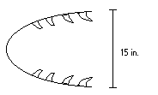

One measurement that is considered is the width of the mouth. **F**irst, researchers have to collect data on several sharks and then make a scatter plot. Use the Numbers below to make a scatter plot.

|  |  |  |  |  |  |  |  |  |  |
| --- | --- | --- | --- | --- | --- | --- | --- | --- | --- |
| Mouth Width (inches) | 16" | 18" | 12" | 17" | 11" | 15" | 17" | 16" | 21" |
| Length of Shark (feet) | 12.3' | 16.2' | 10.4' | 13.6' | 8.2' | 11.7' | 14.7' | 13.6' | 16.9' |

1. Which variable above (Mouth Width or Shark Length) should be the independent variable (the input, x)? Why?
2. Which variable above (Mouth Width or Shark Length) should be the dependent variable (the output, y)? Why?
3. Make a **SCATTER PLOT** of the data at the right.

1. A trend line is a single straight line that best goes through the ‘center’ of all of the data points.

(**DO NOT JUST CONNECT THE POINTS**)

Fit a **TREND LINE** through the data points. (Using a piece of uncooked spaghetti works well to estimate placement.)

***23”***

***HINT: Use your Trend Line***

***??***

1. 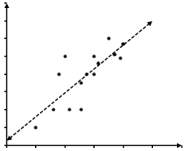Using this trend line, predict the size of a shark based on the width of the mouth. Next, give the approximate size of a shark that has a mouth width of 23".
2. Is your prediction in question #5 the exact same as everyone else in your class?

If it is NOT the same, whose prediction do you think is more accurate?

Who created a better trend line? **Discuss**.

1. What should be the properties of the BEST possible trend line using the given data? **Discuss**.
2. When 2 sets of data have a relatively linear relationship the data is either described as having a **POSTIVE** or **NEGATIVE** correlation. The data correlation is POSITIVE if both data sets move in the same direction (i.e. as one variable increases so does the other). The data correlation is NEGATIVE if the data sets move in opposite directions (i.e. as one variable increases the other decreases). What type of association does this data show?

*M. Winking Unit 6-4 page 150*

1. Most trend lines that are considered to be a “good fit” will be balanced such that the total **RESIDUAL** above and below the trend line is equal. **RESIDUAL** can be defined as the difference between the actual value (y) and expected value $(\hat{y})$. A more succinct definition, **RESIDUAL** can be described as the vertical distance each data point is away from the trend line (with signed difference for above and below the trend line).

Find the **RESIDUAL**s for each of the TREND LINES below (the SCATTER PLOT is the **same** in each graph).

**TREND LINE 2**

**TREND LINE 1**

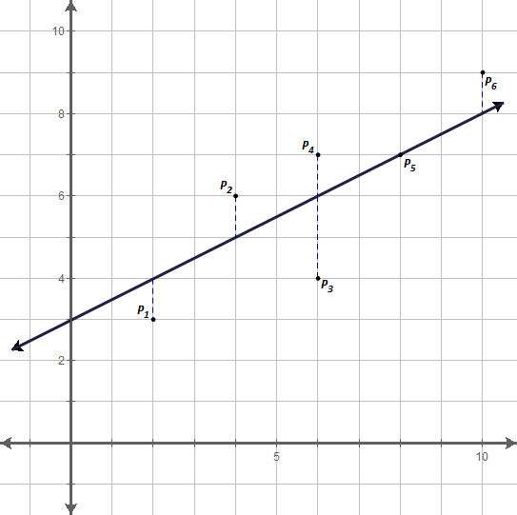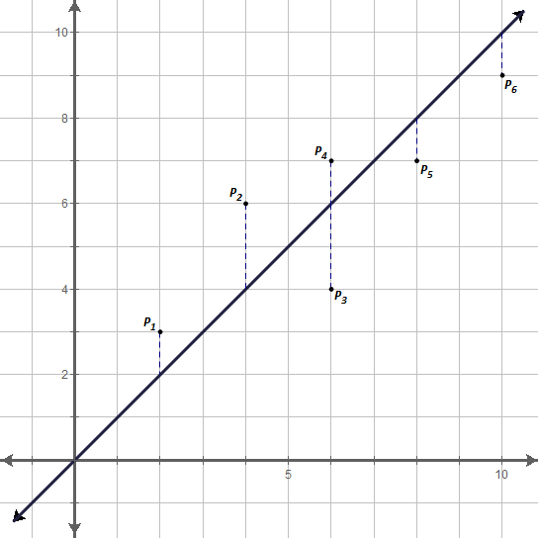

|  |  |
| --- | --- |
| Data Point | Residual |
| P1 | 1 |
| P2 | 2 |
| P3 | –2 |
| P4 |  |
| P5 |  |
| P6 |  |
| Sum of Residuals |  |

|  |  |
| --- | --- |
| Data Point | Residual |
| P1 |  |
| P2 |  |
| P3 |  |
| P4 |  |
| P5 |  |
| P6 |  |
| Sum of Residuals |  |

2

-2

1

**TREND LINE 4**

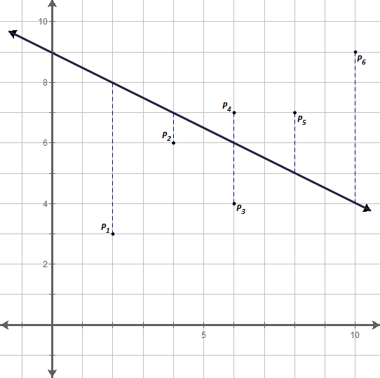

**TREND LINE 3**

|  |  |
| --- | --- |
| Data Point | Residual |
| P1 |  |
| P2 |  |
| P3 |  |
| P4 |  |
| P5 |  |
| P6 |  |
| Sum of Residuals |  |

|  |  |
| --- | --- |
| Data Point | Residual |
| P1 |  |
| P2 |  |
| P3 |  |
| P4 |  |
| P5 |  |
| P6 |  |
| Sum of Residuals |  |

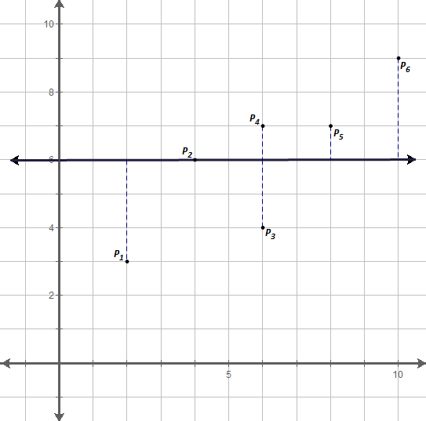

1. What do all 4 trend lies above have in common? *(optional: what is the approximate residual of your trend line from earlier)*

1. To better analyze which trend line is best, it is common to consider comparing the sum of the squares of the residuals. Which trend line do you think is the best based on this new information? Is it the one you expected?

**TREND LINE 1**

|  |  |  |
| --- | --- | --- |
| Data Point | Residual | Residual Squared |
| P1 |  |  |
| P2 |  |  |
| P3 |  |  |
| P4 |  |  |
| P5 |  |  |
| P6 |  |  |
| Sum |  |  |

|  |  |  |
| --- | --- | --- |
| Data Point | Residual | Residual Squared |
| P1 | 1 | 1 |
| P2 | 2 | 4 |
| P3 | –2 | 4 |
| P4 |  |  |
| P5 |  |  |
| P6 |  |  |
| Sum |  |  |

**TREND LINE 4**

**TREND LINE 3**

**TREND LINE 2**

|  |  |  |
| --- | --- | --- |
| Data Point | Residual | Residual Squared |
| P1 |  |  |
| P2 |  |  |
| P3 |  |  |
| P4 |  |  |
| P5 |  |  |
| P6 |  |  |
| Sum |  |  |

|  |  |  |
| --- | --- | --- |
| Data Point | Residual | Residual Squared |
| P1 |  |  |
| P2 |  |  |
| P3 |  |  |
| P4 |  |  |
| P5 |  |  |
| P6 |  |  |
| Sum |  |  |

*M. Winking Unit 6-4 page 151*

1. The line that minimizes the squares is called the LEAST SQUARES REGRESSION LINE. Most scientific calculators are capable of determining the equation of this trend line. Consider again the data about sharks. **The following are the directions for the TI-83/84:**

1. First, it will be helpful to turn on additional diagnostic information in your calculator.

*SCROLL DOWN TO DianosticOn*

*CATALOG*

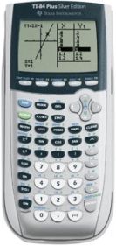

 …….…

1. Under the Stat menu, press.

*(This just resets the list menus)*

1. Next, press



1. If there is OLD data already in the lists that needs to be cleared press the up arrow, ,  to highlight L1 and then press  to clear out the old data. Do the same for L2 if it has OLD data that needs to be cleared.

To clear out **OLD** data, first highlight **L1** and press CLEAR, ENTER.



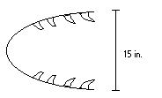

1. Next, enter the Shark’s Mouth Size in L1 and the Length of the Shark in L2.



1. 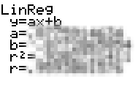Return to the home screen by pressing  and then to calculate the linear regression press .
2. This represents the an equation of a line that minimizes the total residuals squared.

Fill in the blanks to complete the LEAST SQUARES REGRESSION LINE equation.

**y =**  •**x +**

*b*

*a*

Use this equation to reattempt your prediction of a shark with a 23” mouth.

**y =**  •**(23) + =**

*a*

*b*

Now, was this close to your original prediction?

1. When a prediction is made between two given data points the prediction is called an **INTERPOLATION**. When a prediction is made outside the range of given data points the prediction is an **EXTRAPOLATION**. Which type of prediction was used when you predicted the length of a shark with a 23” wide mouth?

35 = •x +

a

b

1. In the movie JAWS the shark was approximately 35 feet in length, based on the equation you just calculated, how wide would his mouth be? (careful the length might be represented by x)

Would it be large enough to bite the back end of a boat (consider even a small boat is 48 inches wide)?

*M. Winking Unit 6-4 page 152*

1. A calculation called the **correlation coefficient (r)** is used to measure the extent to which the data for the two variables show a linear relationship. The closer the value is to 1 or –1 the stronger the linear relationship.

Weak

Strong

None

Weak

Strong



***r:***

Perfect

Negative

Linear

Relationship

0

No

Linear

Relationship

Perfect

Positive

Linear

Relationship

1. Match the correct Correlation Coefficient with the correct scatter plot:

D.

A.

B.

C.

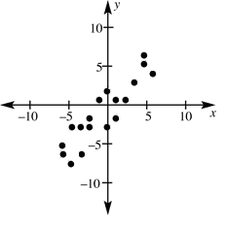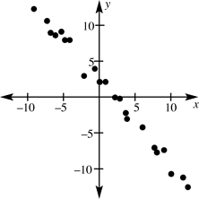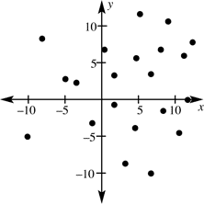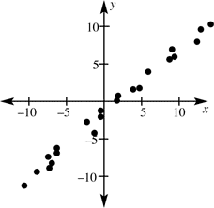

r ≈ 0. 98

r ≈ – 0. 96

r ≈ 0.61

r ≈ 0.17



1. 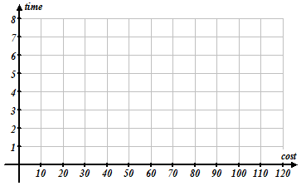 Create a scatter plot and approximate a trend line of best fit based on the data below

|  |  |  |
| --- | --- | --- |
| **Model** | **Cost of Car** | **0-60 mph**  **acceleration** |
| Scion xB | $16 K | 7.8 sec |
| Mitsubishi Eclipse | $24 K | 6.1 sec |
| Chev. Corvette | $106 K | 3.4 sec |
| Nissan GT-R | $76 K | 3.5 sec |
| SSC Ultimate Aero | $42 K | 4.8 sec |
| Lotus Elise | $60 K | 4.4 sec |
| Honda Civic Si | $22 K | 6.7 sec |

a.

2. Using your calculator determine the approximate linear regression line that best fits the data.

**y =** **.x +**

(a) (b)

*3c.*

1. Use your model, to predict the 0-60mph time of a car that costs $30 K?
2. Was your prediction in problem (part c) an extrapolation or interpolation?

Extrapolation Interpolation

*3d.*

1. Use your model, to predict how much a car would cost that can do 0 – 60 mph in 4.0 seconds. (Show Work!)

*3e*

*.*

*M. Winking Unit 6-4 page 153*

1. Determine the sum of the square of the residuals for each trend line below (the scatter plot is the same for each graph).

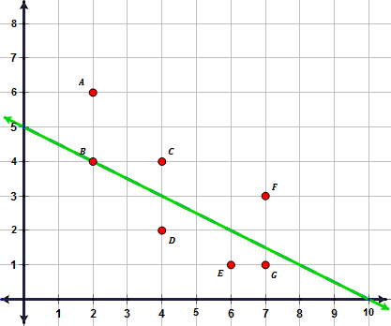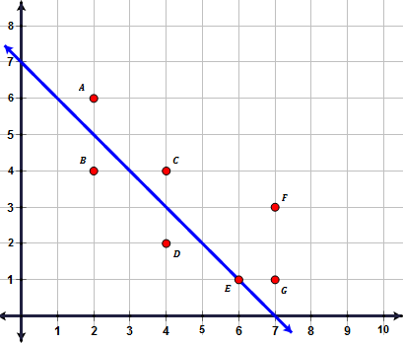

**Trend Line A**

**Trend Line B**

**Sum of the square of residuals for Trend Line B:**

**Sum of the square of residuals for Trend Line A:**

Which is a better trend line based on the sum of the squares of the residuals?

1. Consider the following Table of Values that might be used to create a scatter plot.

|  |  |  |  |  |  |
| --- | --- | --- | --- | --- | --- |
| **x** | 1 | 2 | 3 | 4 | 5 |
| **y** | 2 | 5 | 4 | 6 | 12 |

Which trend line equation has a smaller sum of the squares of the residual?

**Trend Line A: $\hat{y}=2\hat{x}$**  **Trend Line B: $\hat{y}=0.5\hat{x}+1$**

|  |  |  |  |  |  |
| --- | --- | --- | --- | --- | --- |
| x | 1 | 2 | 3 | 4 | 5 |
| y | 2 | 5 | 4 | 6 | 12 |
| $$\hat{y}$$ |  |  |  |  |  |
| Residual |  |  |  |  |  |
| Residual2 |  |  |  |  |  |

|  |  |  |  |  |  |
| --- | --- | --- | --- | --- | --- |
| x | 1 | 2 | 3 | 4 | 5 |
| y | 2 | 5 | 4 | 6 | 12 |
|  |  |  |  |  |  |
| Residual |  |  |  |  |  |
| Residual2 |  |  |  |  |  |

*M. Winking Unit 6-4 page 154*